Orthodox Marketplace

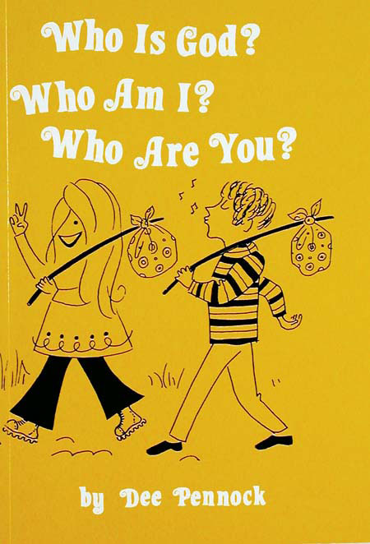
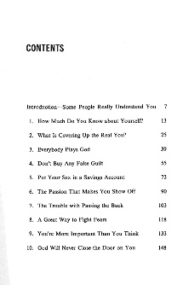

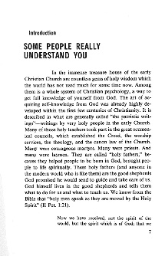

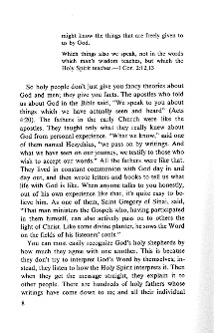

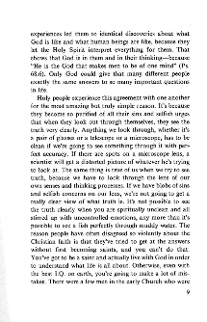

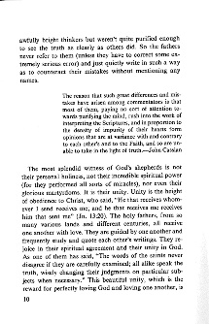

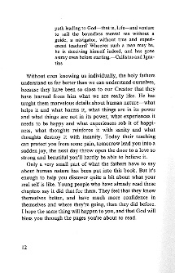

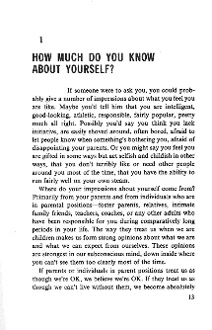

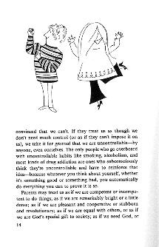
Who is God, Who Am I, Who Are You - Student
Based on the teachings of inspired early Christian fathers, this book describes the potential of every person and how to bring it about in everyday life—by growing up spiritually. This is a creatively illustrated book addressing relationships: to each other, to oneself, to God. The lessons focus on our spiritual and psychological lives as they relate to the teachings of the Church. Student Book.

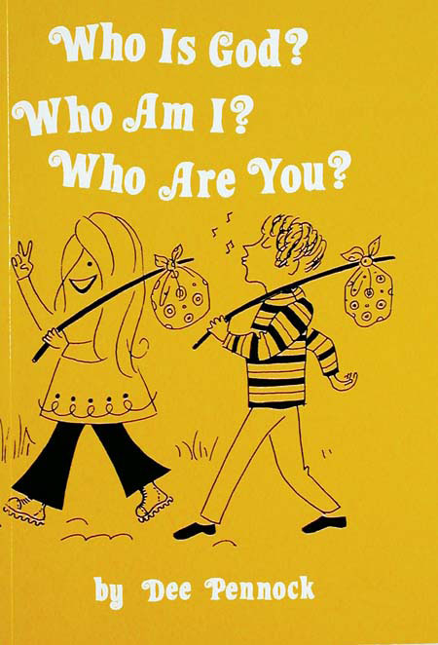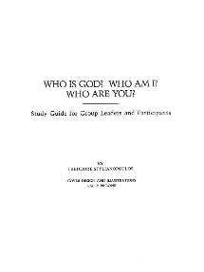

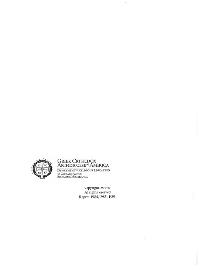

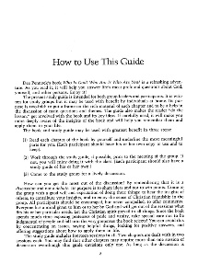

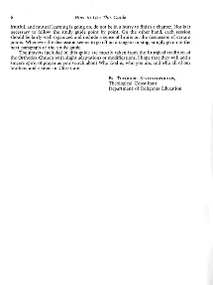

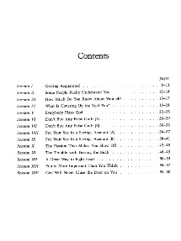

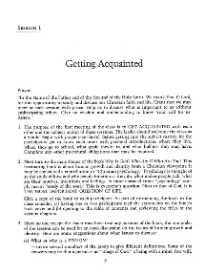

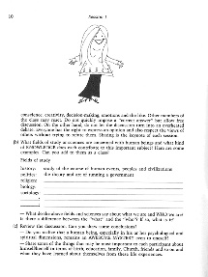

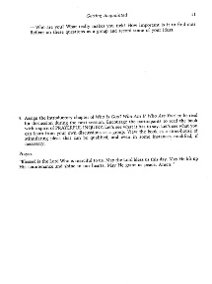
Who is God, Who Am I, Who Are You - Study Guide
Based on the teachings of inspired early Christian fathers, this book describes the potential of every person and how to bring it about in everyday life—by growing up spiritually. This is a creatively illustrated book addressing relationships: to each other, to oneself, to God. The lessons focus on our spiritual and psychological lives as they relate to the teachings of the Church. Study Guide.

