Orthodox Marketplace
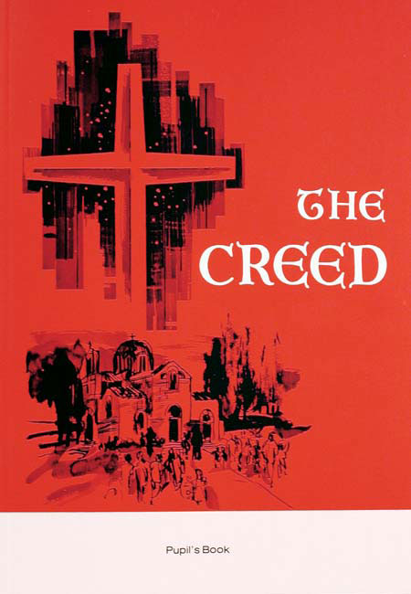
The Creed - Student
This discussion of the Nicene Creed—the foundation of our Faith—begins with a review of Christianity, the Church and Tradition. It offers a definition and an explanation of the Creed. Student Book

