Orthodox Marketplace

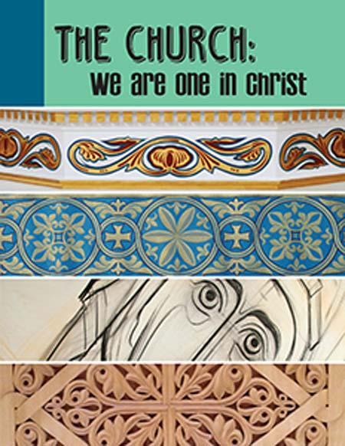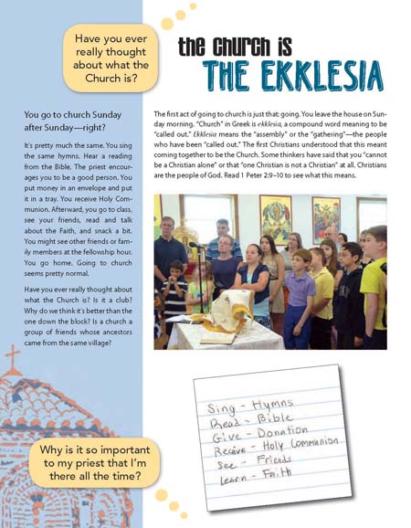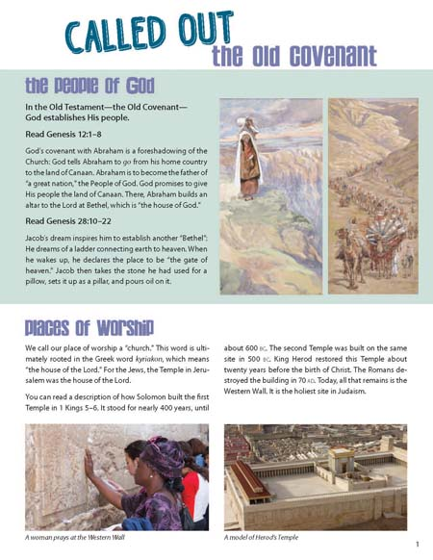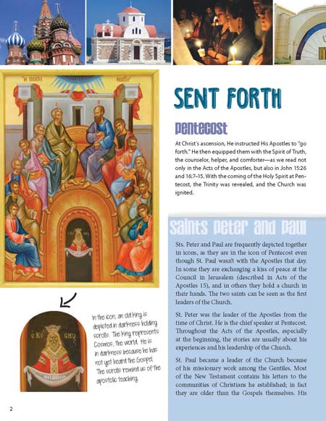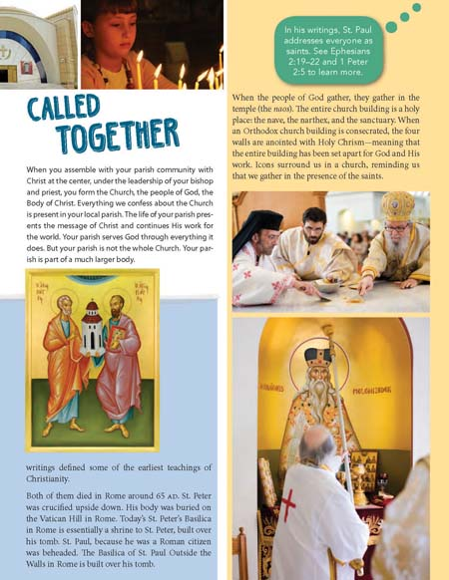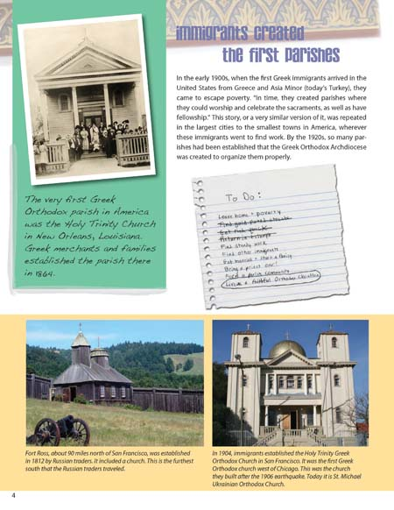
The Church: We are One in Christ Student Book
This colorful and energetic zine explores what the Church; the Body of Christ, a community united in Him which we enter into through Baptism. It outlines its formation and development from Apostolic times to the present day, explores its worship and describes its various manifestation in our world. Student Book

