Orthodox Marketplace
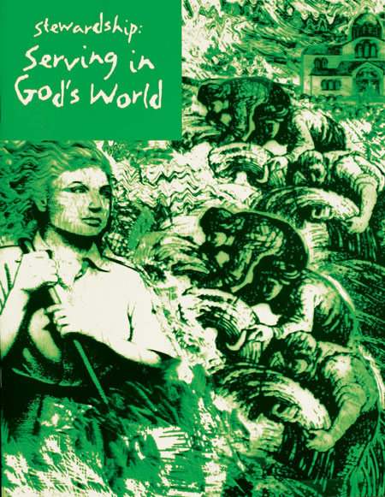
Stewardship: Serving in God's World - Student
All too often stewardship is equated with money, which is far too limited for a Christian perspective. The five lessons in this unit expand the vision of stewardship from the environment to our role of responsibility to each other, and focuses on the broad concepts of stewardship that will contribute to spiritual growth. Student Book.
Stewardship: Serving in God's World - Teacher
All too often stewardship is equated with money, which is far too limited for a Christian perspective. The five lessons in this unit expand the vision of stewardship from the environment to our role of responsibility to each other, and focuses on the broad concepts of stewardship that will contribute to spiritual growth. Teacher Guide.

