Orthodox Marketplace
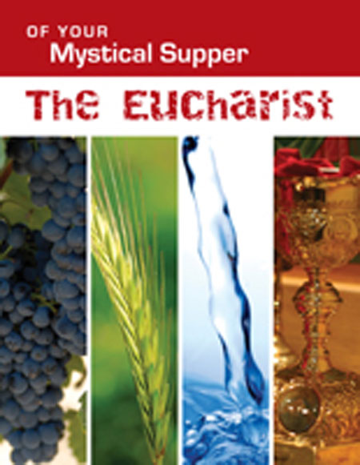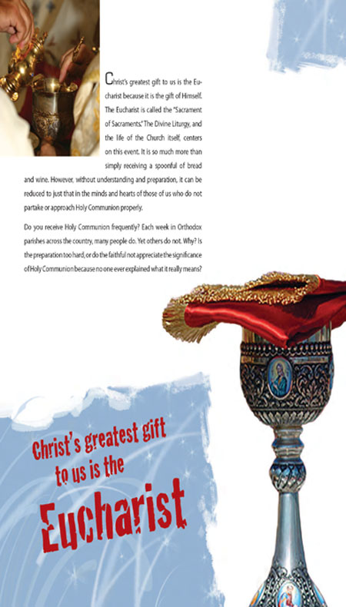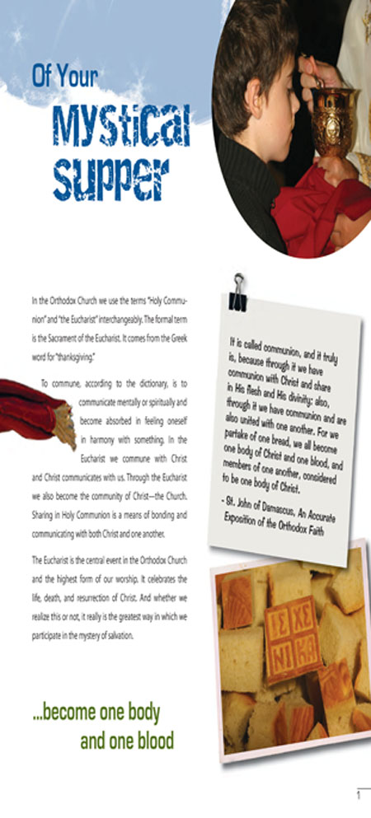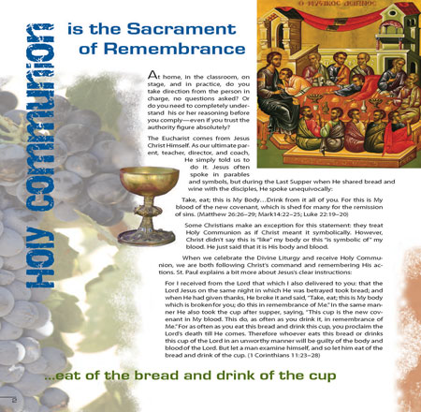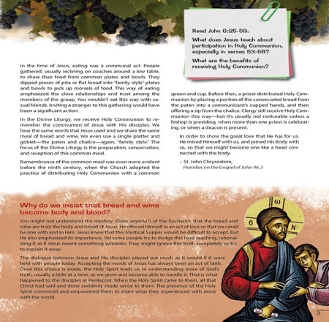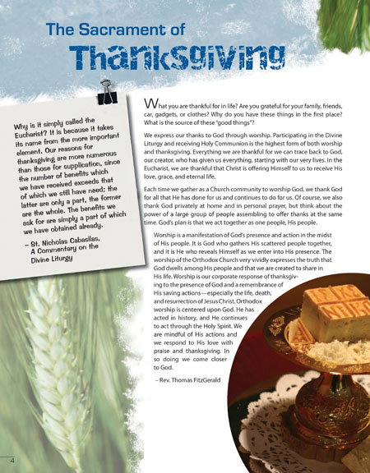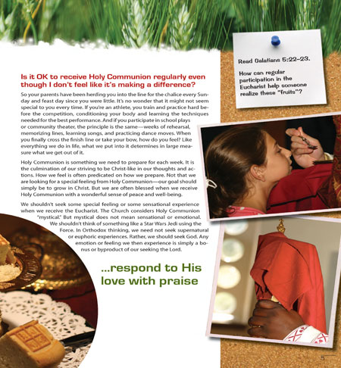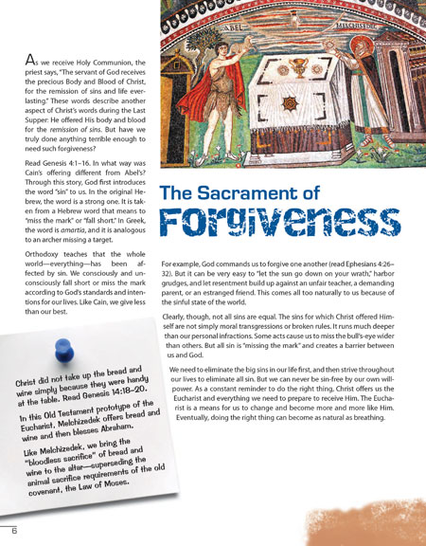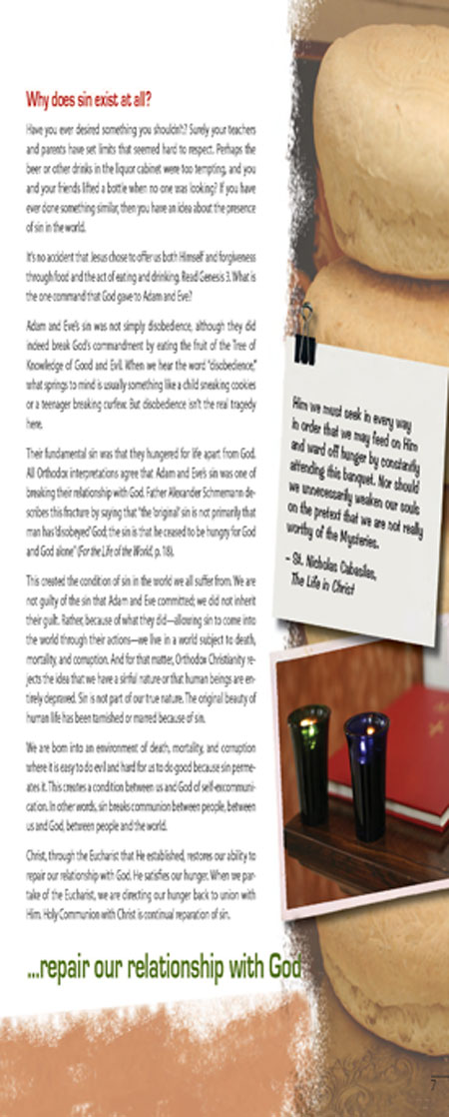
Of Your Mystical Supper - Eucharist Zine - Student
Through the themes of remembrance, thanks¬giving, forgiveness, and community, this zine explores the mystery of the Eucharist. The text introduces the fullness of the Church’s teachings with Scripture and excerpts from the Fathers. (Age 13+) Student Book.

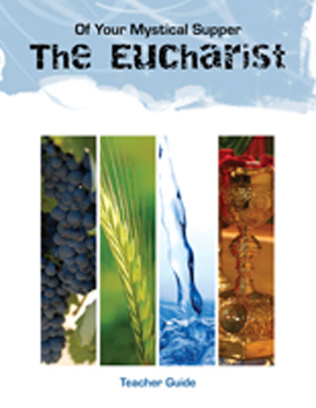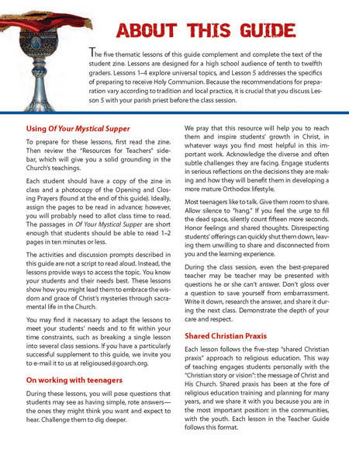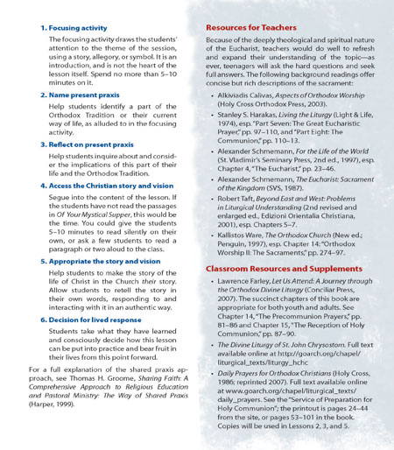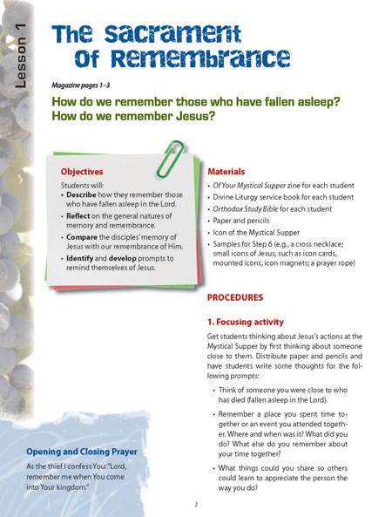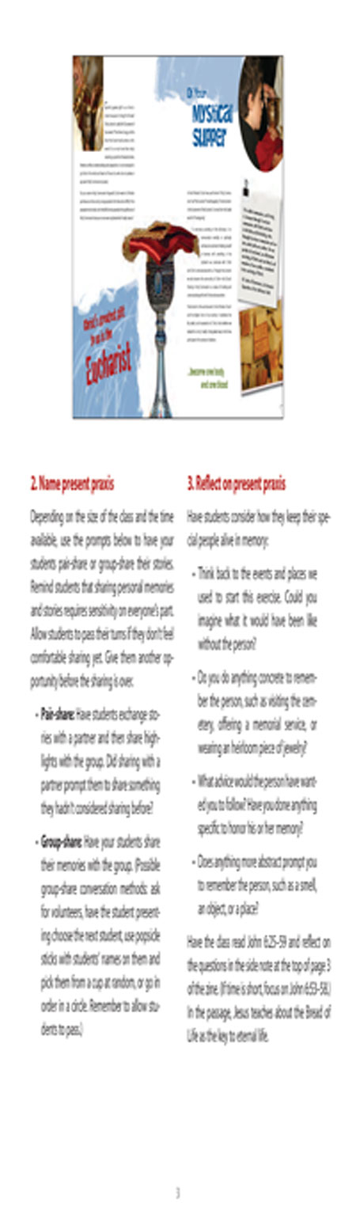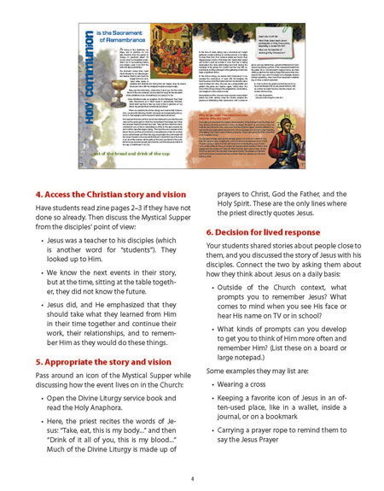
Of Your Mystical Supper - Eucharist Zine - Teacher
Through the themes of remembrance, thanks¬giving, forgiveness, and community, this zine explores the mystery of the Eucharist. The text introduces the fullness of the Church’s teachings with Scripture and excerpts from the Fathers. The Teacher Guide completes and supports the zine’s text with ac¬tivities and discussion guides (Age 13+)

