Orthodox Marketplace 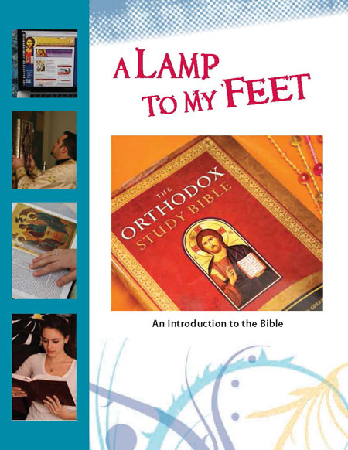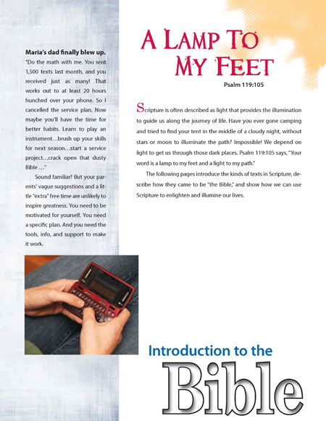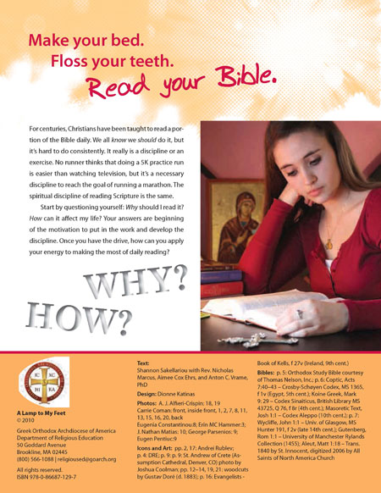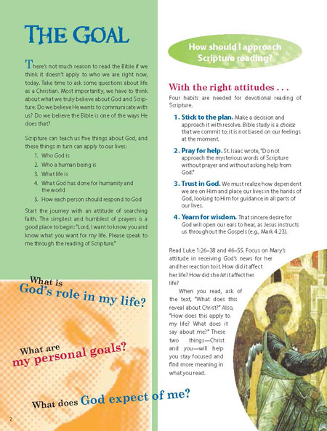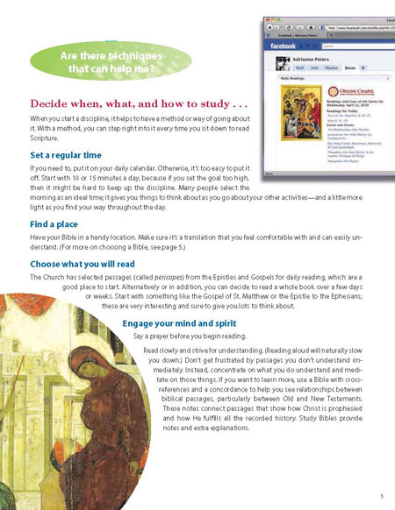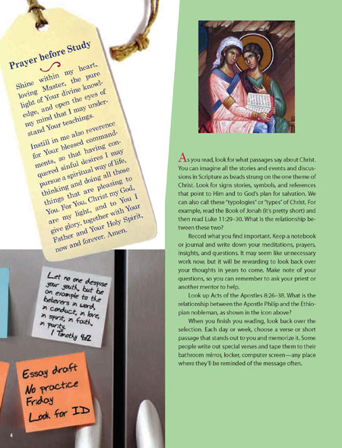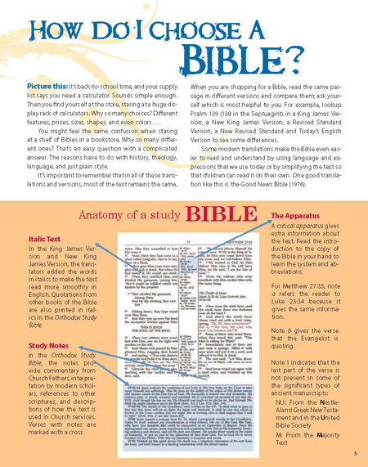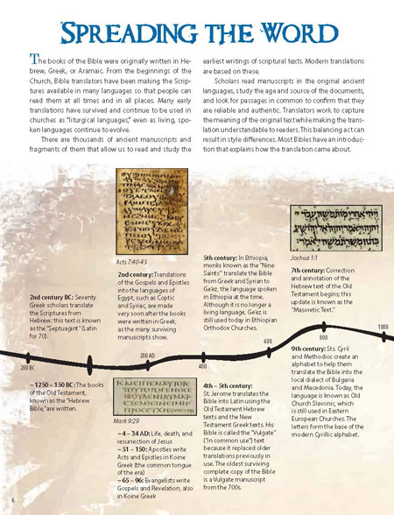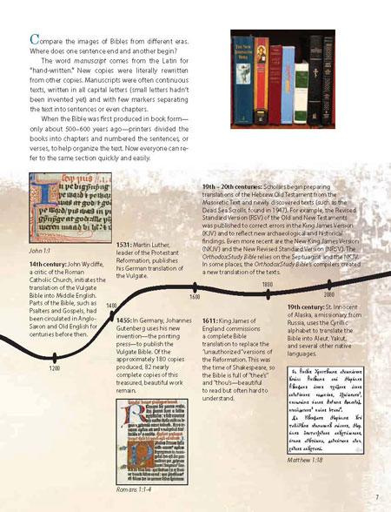

A Lamp to My Feet: An Introduction to the Bible - Student
With this zine, students develop the attitudes and confidence needed to light their path with the lamp of Scripture. Students learn to access God’s message to the world by asking how each reading relates to them: “What does this text say about Christ, and how does it apply to my life?” The zine explores goals of Bible study; study habits and methods; and Bible formats and translations. It introduces the Old and New Testaments, the kinds of books in them, and how the books came to be there. (Age 12+) Student Zine.
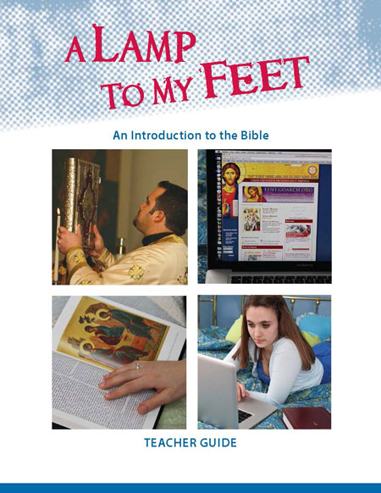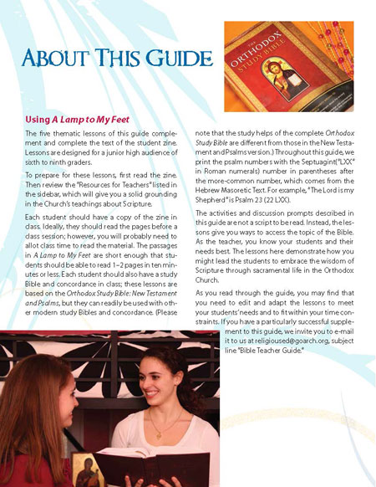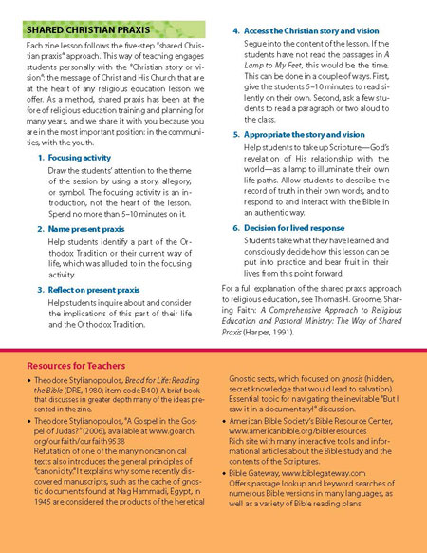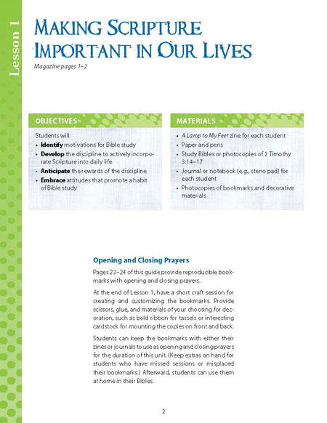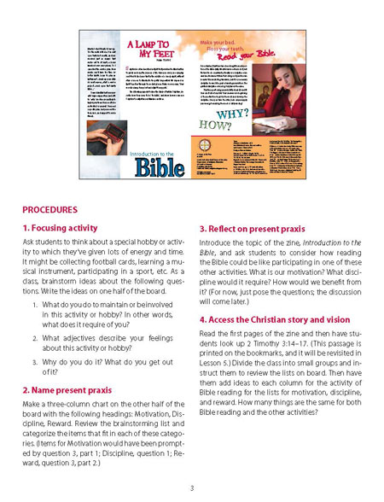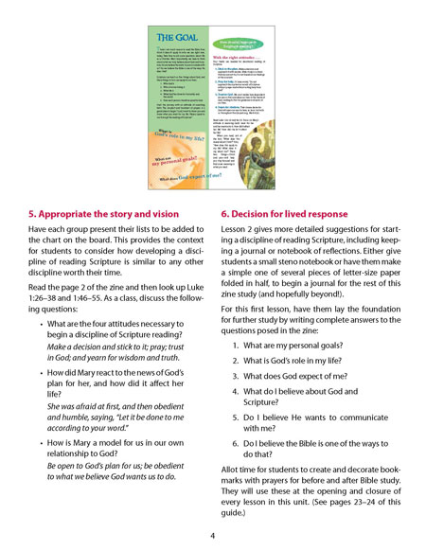
A Lamp to My Feet: An Introduction to the Bible – Teacher Guide
With this zine, students develop the attitudes and confidence needed to light their path with the lamp of Scripture. Students learn to access God’s message to the world by asking how each reading relates to them: “What does this text say about Christ, and how does it apply to my life?” The zine explores goals of Bible study; study habits and methods; and Bible formats and translations. It introduces the Old and New Testaments, the kinds of books in them, and how the books came to be there. The Teacher Guide provides interactive lessons and practice tangling with difficult passages. (Age 12+) Teacher Guide.

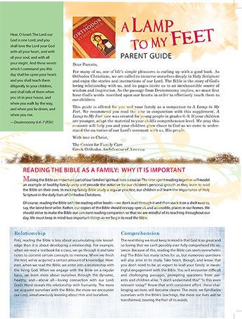
A Lamp to My Feet: An Introduction to the Bible Parent Guide (PDF)
This digital download from Center for Family Care extends A Lamp to My Feet, a zine from the Department of Religious Education, into your home!

