Orthodox Marketplace

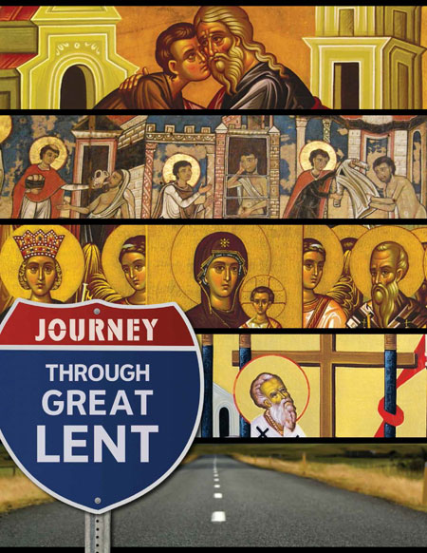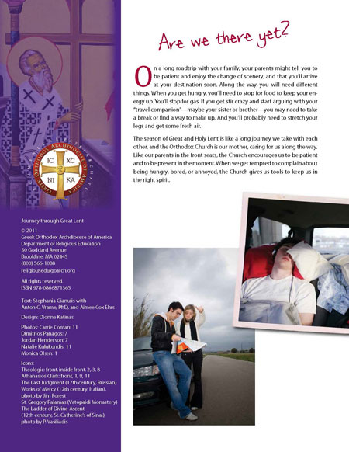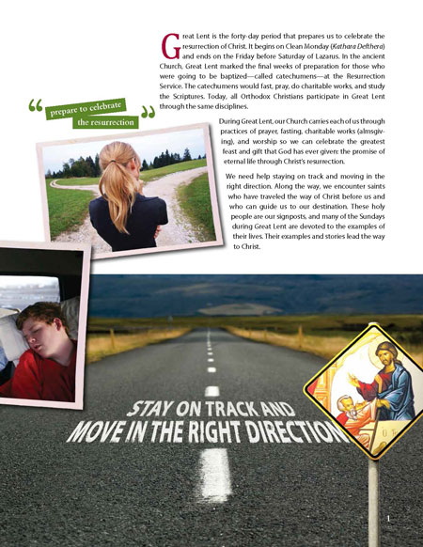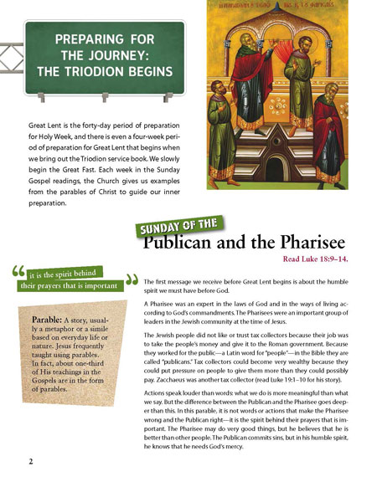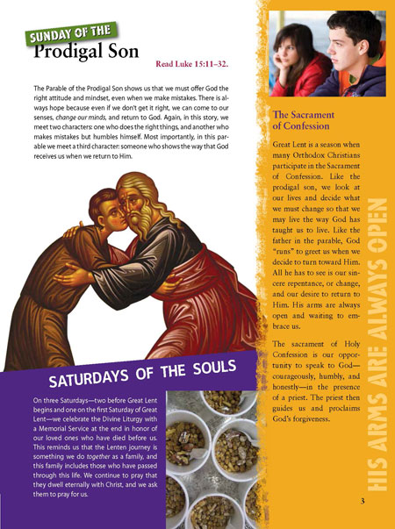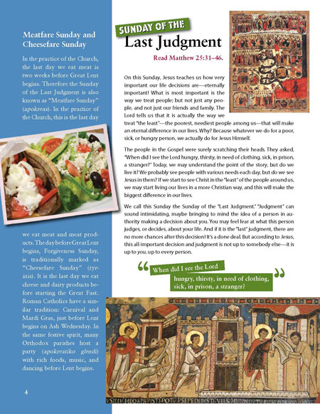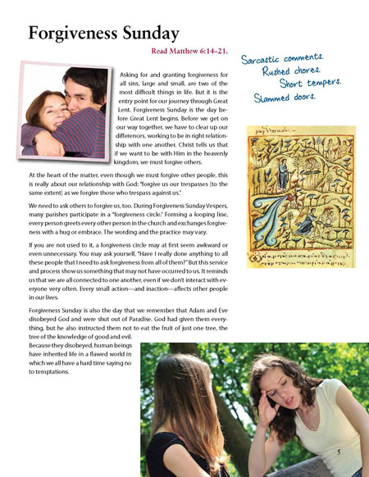
Journey Through Great Lent Zine - Student
This nine-week unit spans the Great Fast with clear, vivid introductions to the season’s scriptures, traditions, saints, and services. The brief readings in the zines are a focal point in classroom lessons that include not only personal reflection and thoughtful discussion, but also interactive activities and projects to help students refuel. Journal assignments keep students focused all week long on the disciplines of the Great Fast: fasting, prayer, giving and learning. Includes an in-depth lesson on the Sacrament of Confession. (Age 12+) Student Zine.

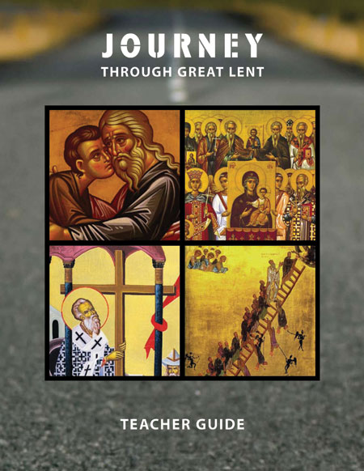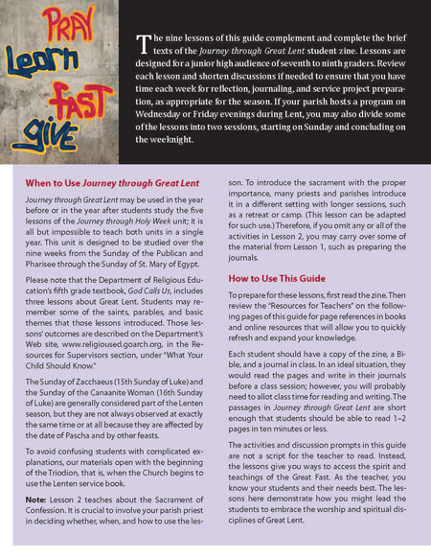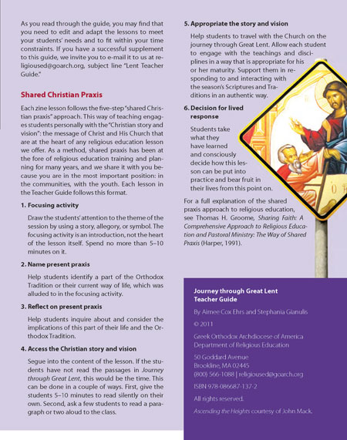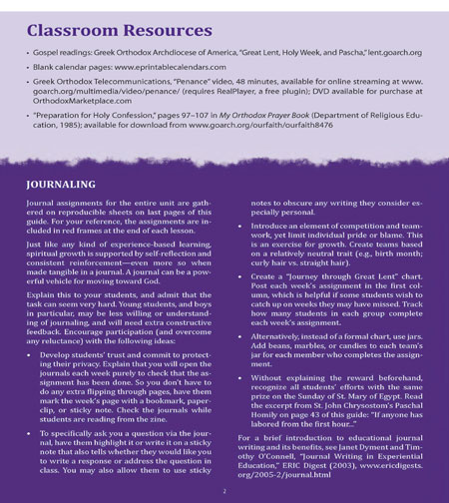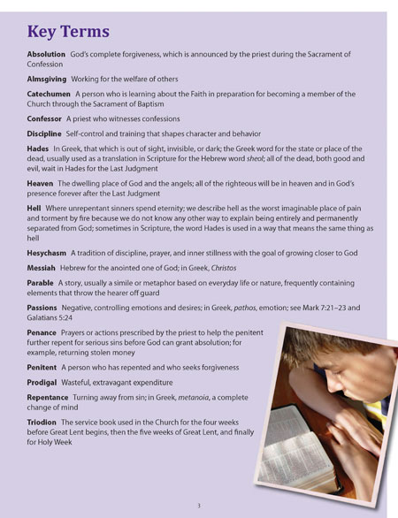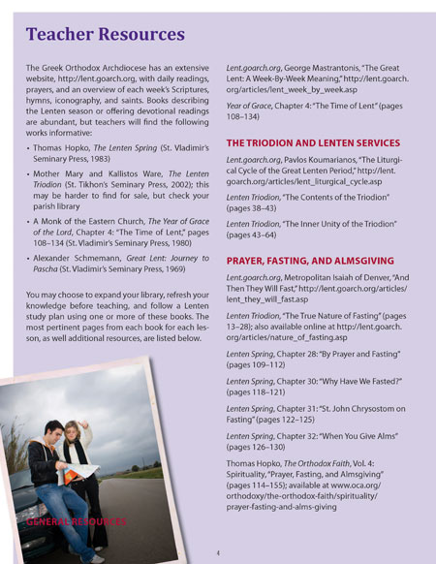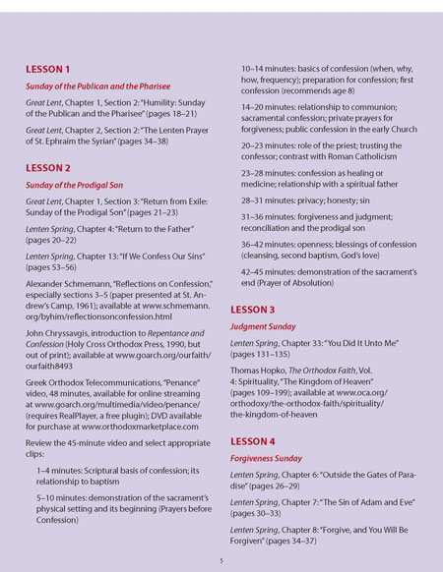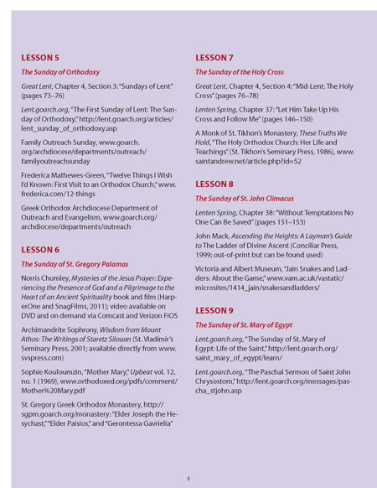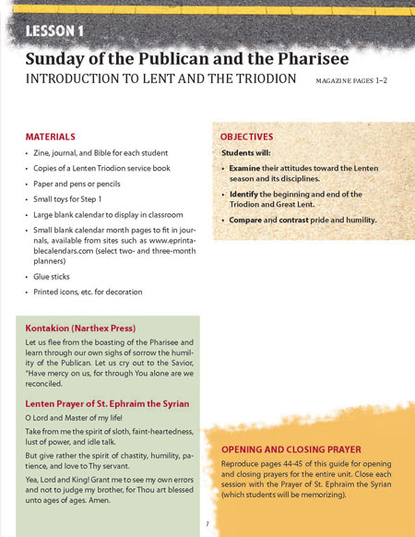
Journey Through Great Lent Zine - Teacher

This nine-week unit spans the Great Fast with clear, vivid introductions to the season’s scriptures, traditions, saints, and services. The brief readings in the zines are a focal point in classroom lessons that include not only personal reflection and thoughtful discussion, but also interactive activities and projects to help students refuel. Journal assignments keep students focused all week long on the disciplines of the Great Fast: fasting, prayer, giving and learning. Includes an in-depth lesson on the Sacrament of Confession. (Age 12+) Teacher Guide.

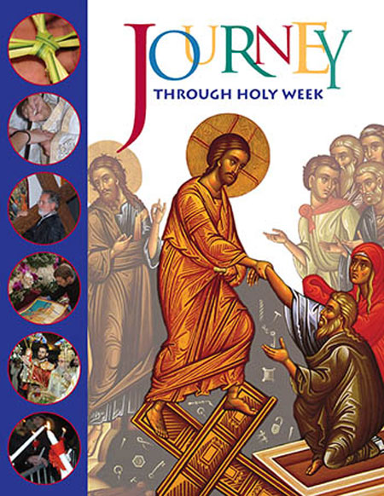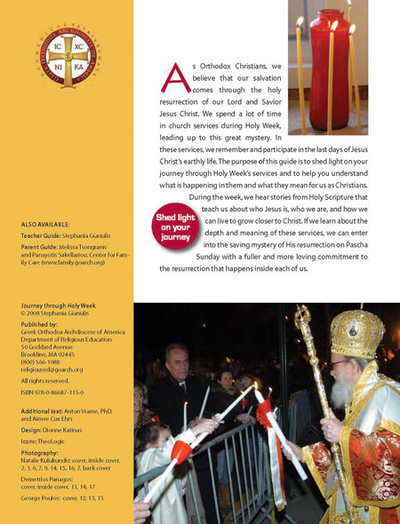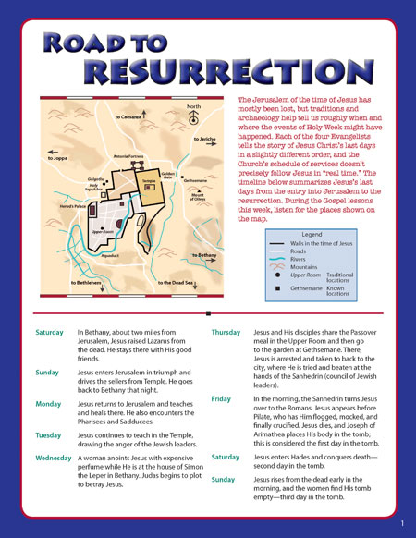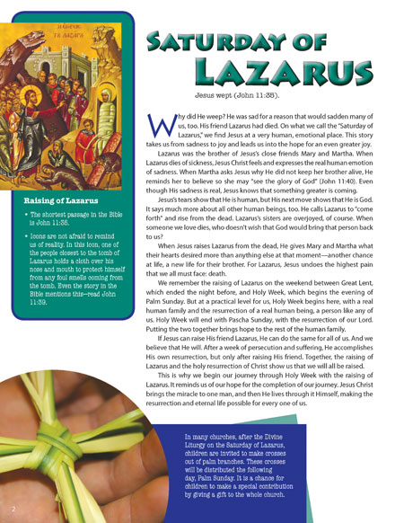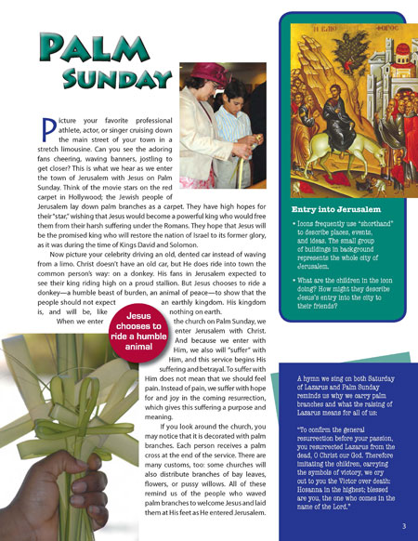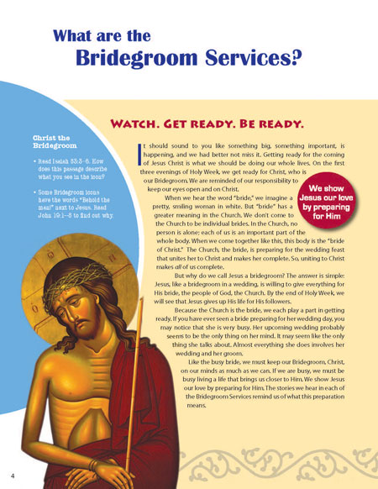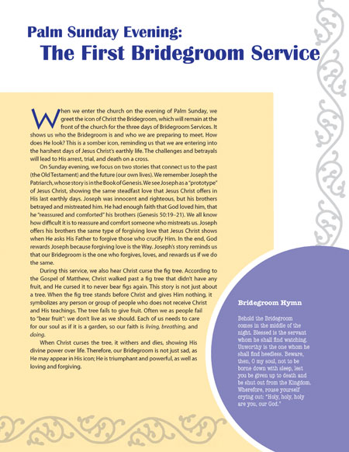
Journey through Holy Week Zine - Student
Follow Christ and the Church from the Saturday of Lazarus to the Agape Vespers service. The zine pinpoints the relevance and meanings of the services, hymns, Scripture, icons, traditions and history. In addition to the classroom, the zine can be used during retreats, in the church or at home. (Age 10 +) Student Zine
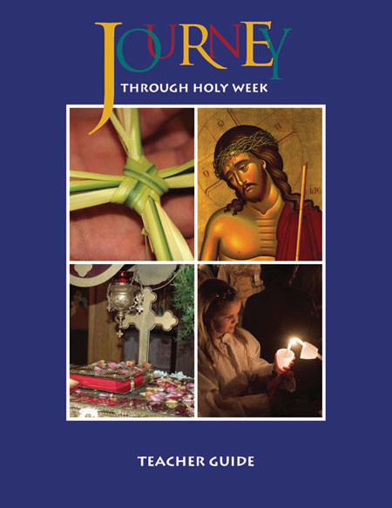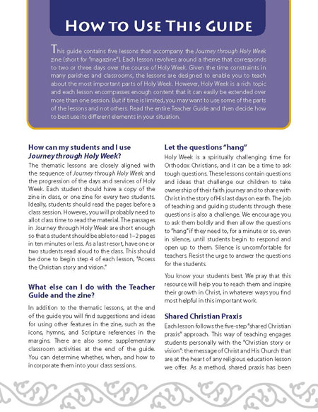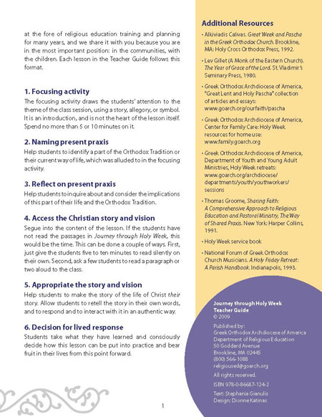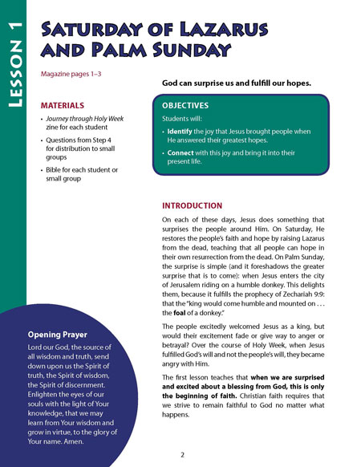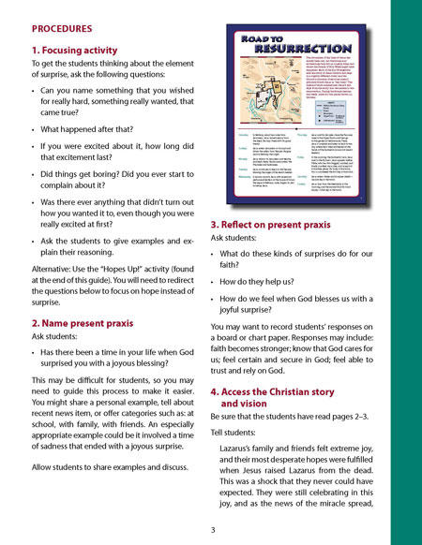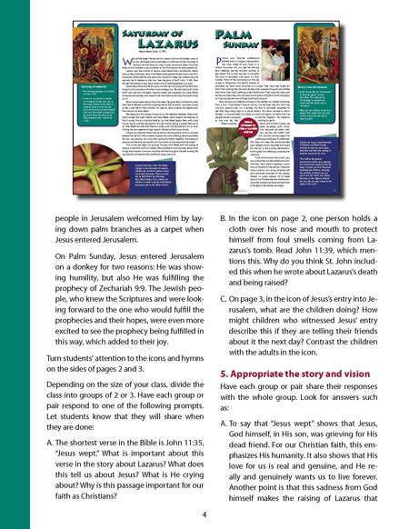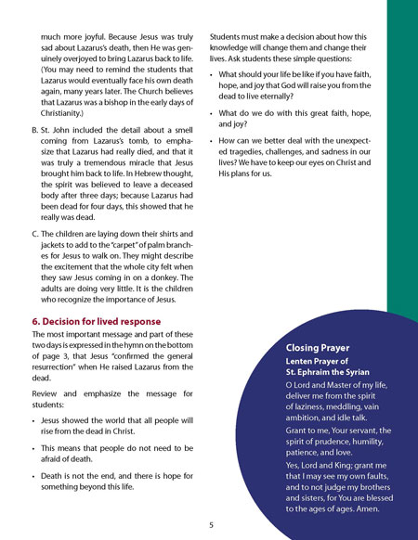
Journey through Holy Week Zine - Teacher
Follow Christ and the Church from the Saturday of Lazarus to the Agape Vespers service. The zine pinpoints the relevance and meanings of the services, hymns, Scripture, icons, traditions and history. In addition to the classroom, the zine can be used during retreats, in the church or at home. Each lesson in the Teacher Guide focuses on a theme: surprise and hope (Lazarus Saturday and Palm Sunday); living in preparation for meeting Christ (Bridegroom Services); and healing and wholeness (Holy Wednesday). (Age 10+) Teacher Guide. 1 Unit of 5 Lessons.

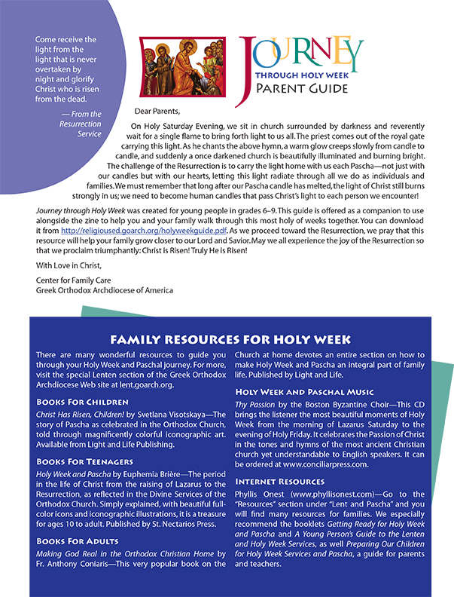
Journey through Holy Week Parent Guide (PDF)
This digital download from Center for Family Care extends Journey through Holy Week, a zine from the Department of Religious Education, into your home!

