Orthodox Marketplace

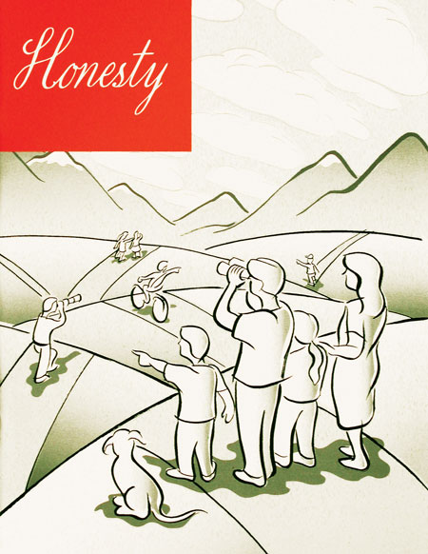
Honesty - Student
Honesty is a broad topic, but knowing the consequences of lying, cheating, and distinguishing right from wrong are essential for our youth and their spiritual welfare. The Bible and the teaching of Christ constitute a strong moral compass for such guidance and direction. In the vignette of each lesson Andre’s good friends, Constance and Anna, pose some real-life problems for Andre. Student Book

Honesty - Teacher
Honesty is a broad topic, but knowing the consequences of lying, cheating, and distinguishing right from wrong are essential for our youth and their spiritual welfare. The Bible and the teaching of Christ constitute a strong moral compass for such guidance and direction. In the vignette of each lesson Andre’s good friends, Constance and Anna, pose some real-life problems for Andre. Teacher Guide.

