Orthodox Marketplace

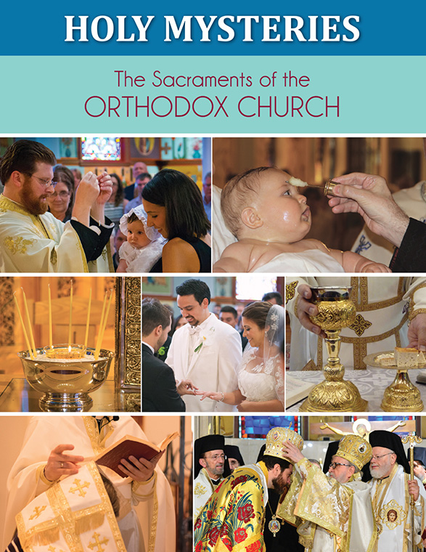
Holy Mysteries: The Sacraments of the Orthodox Church Student Book
For centuries, the Orthodox Church has named seven sacraments: baptism, chrismation, the Eucharist, confession, priesthood, marriage and unction. They unite us with God by bringing together the visible and the invisible, the physical and the spiritual.

In our newest zine for junior and senior high school students, each sacrament is first examined in terms of its significance and its connections to the actions of everyday life: bathing, eating, drinking, touching, being a family. Next, the text explores the rite for each sacrament, showing how the Church uses these ordinary activities and adds prayer, thanksgiving and the words of Christ to make them acts of extraordinary importance.

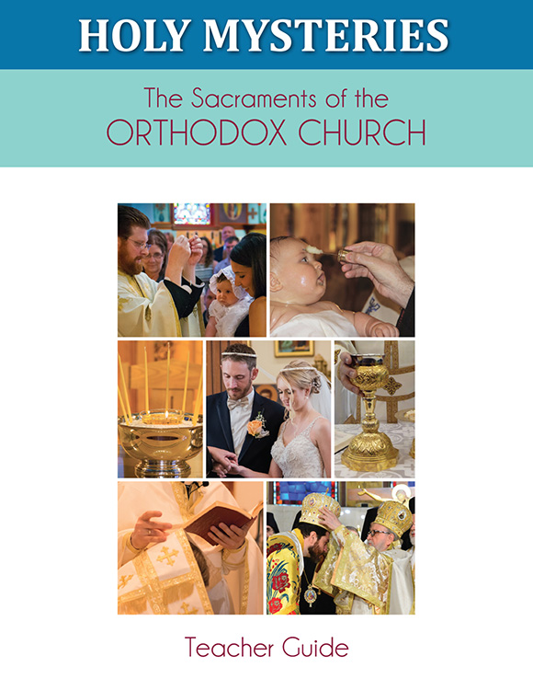
Holy Mysteries: The Sacraments of the Orthodox Church Teacher Guide
For centuries, the Orthodox Church has named seven sacraments: baptism, chrismation, the Eucharist, confession, priesthood, marriage and unction. They unite us with God by bringing together the visible and the invisible, the physical and the spiritual.

In our newest zine for junior and senior high school students, each sacrament is first examined in terms of its significance and its connections to the actions of everyday life: bathing, eating, drinking, touching, being a family. Next, the text explores the rite for each sacrament, showing how the Church uses these ordinary activities and adds prayer, thanksgiving and the words of Christ to make them acts of extraordinary importance. 1 Unit of 11 Lessons.

