Orthodox Marketplace

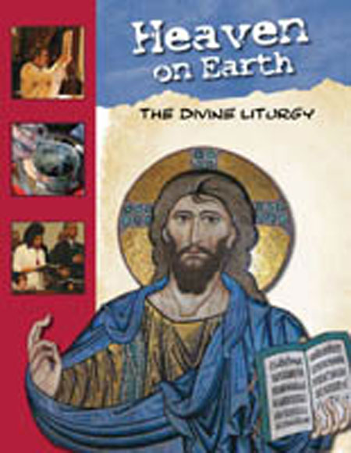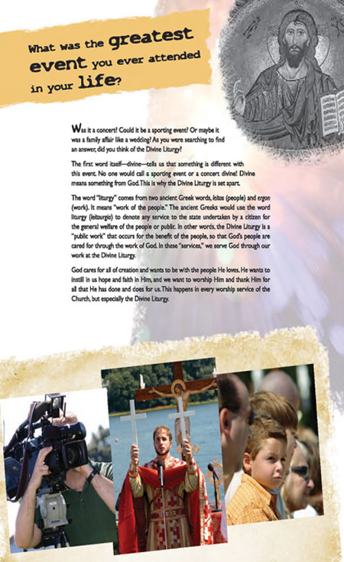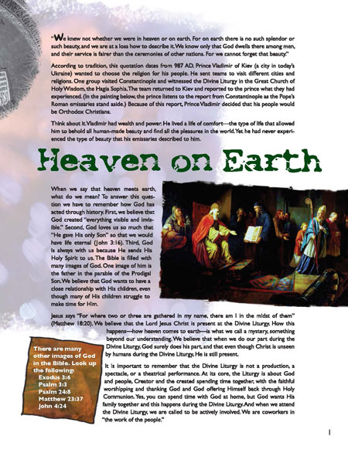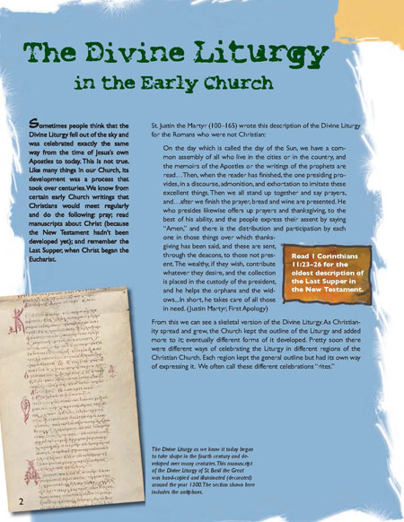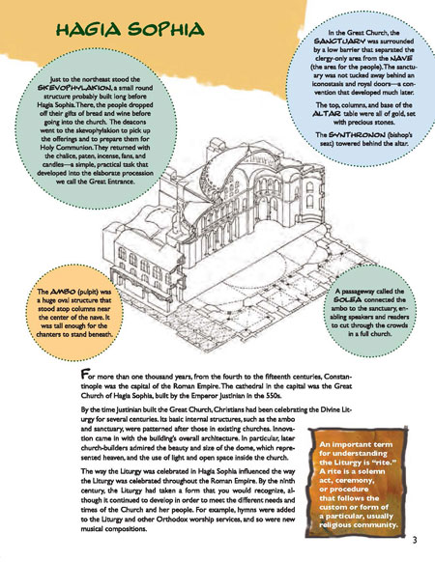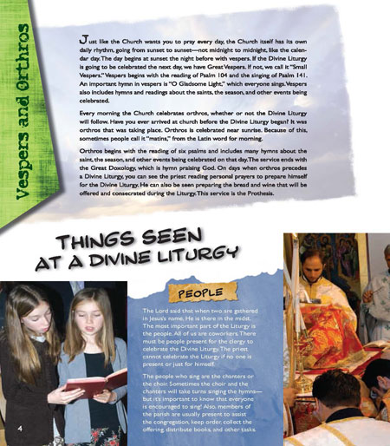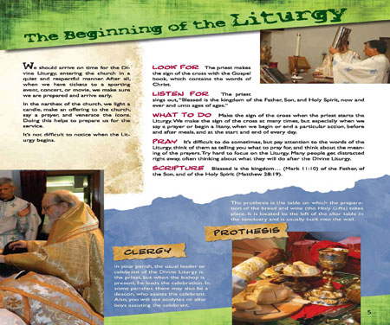
Heaven on Earth: The Divine Liturgy Zine - Student
“We knew not whether we were in heaven or on earth . . . We know only that God dwells there among men.” As St. Vladimir’s emissaries found, heaven and earth meet in the Church through the Divine Liturgy. The zine begins with a brief history of worship in the Orthodox Church and then details each section of the service. Special features include a “visual dictionary” of liturgical items, a look at Church architecture, and an exploration of the Creed’s scriptural foundations. (Age 10+) Student Zine.

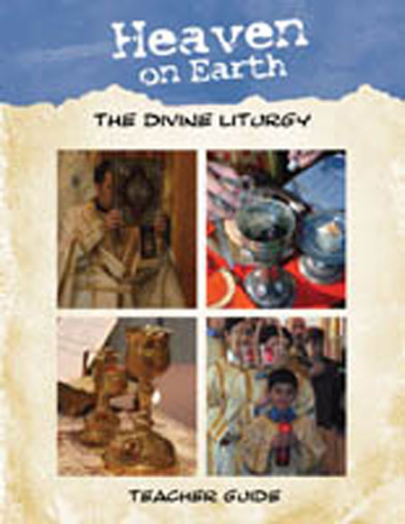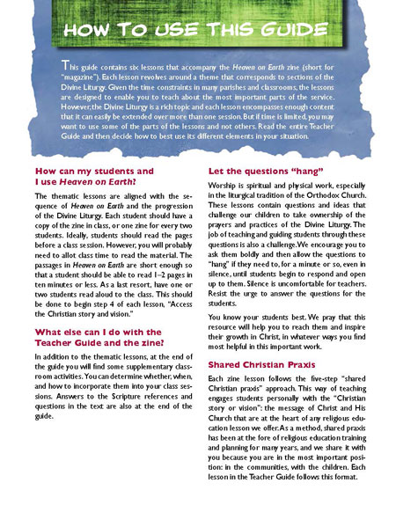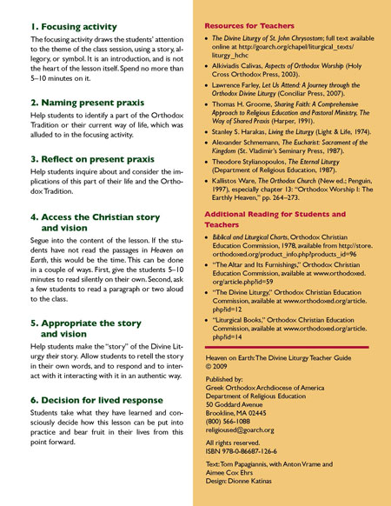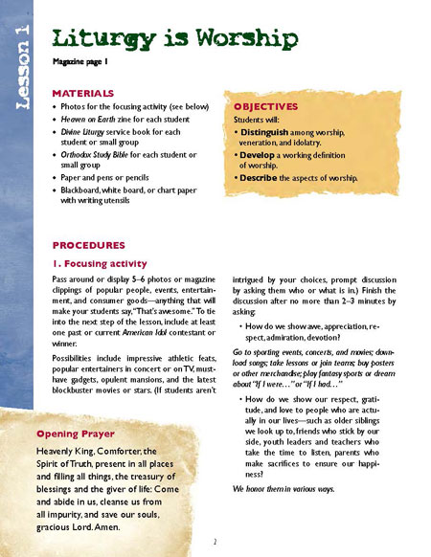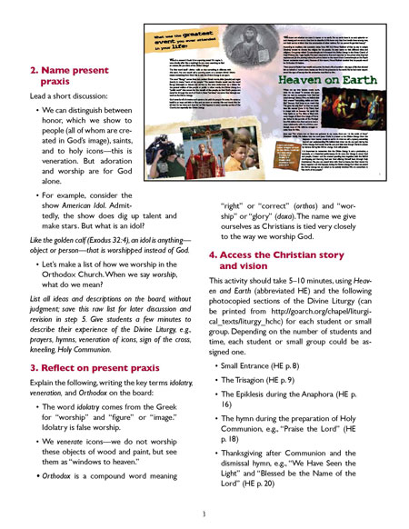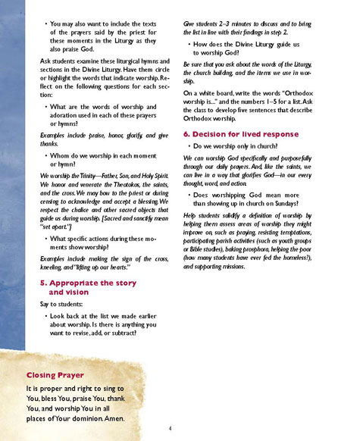
Heaven on Earth: The Divine Liturgy Zine - Teacher
“We knew not whether we were in heaven or on earth . . . We know only that God dwells there among men.” As St. Vladimir’s emissaries found, heaven and earth meet in the Church through the Divine Liturgy. The zine begins with a brief history of worship in the Orthodox Church and then details each section of the service. Special features include a “visual dictionary” of liturgical items, a look at Church architecture, and an exploration of the Creed’s scriptural foundations. Each lesson in the Teacher Guide helps students understand and engage with one aspect of the Divine Liturgy: worship, unity, prayer, Scripture, forgiveness, and the “liturgy after the liturgy.” (Age 10+)

