Orthodox Marketplace
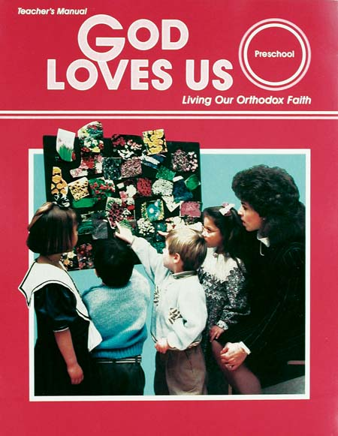
Preschool: God Loves Us Teacher Manual
This is a teacher’s guide with reproducible handouts for your students. Love, which children so freely give and so naturally expect, is the basis for this program. Here are the materials a teacher needs to build an effective, customized program for this age group.

