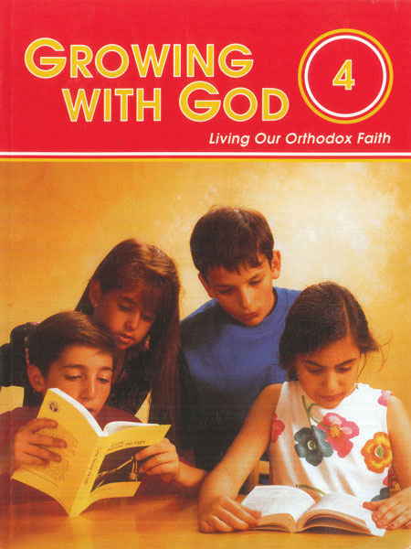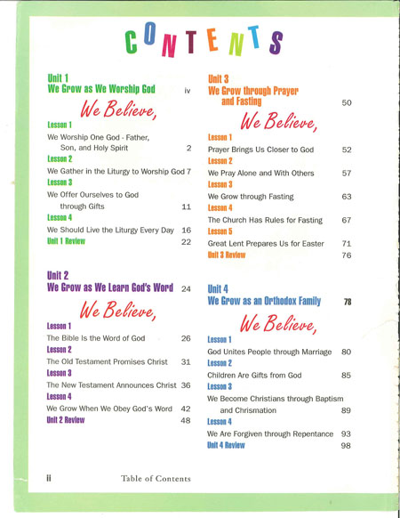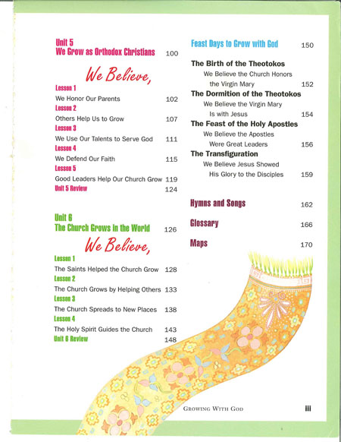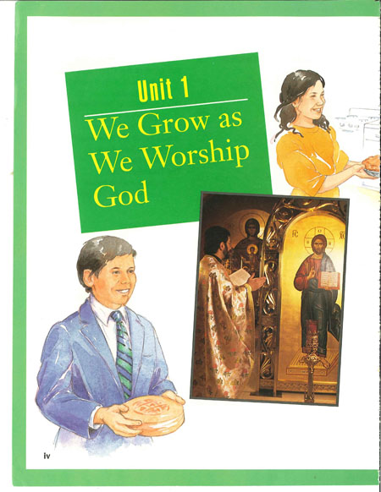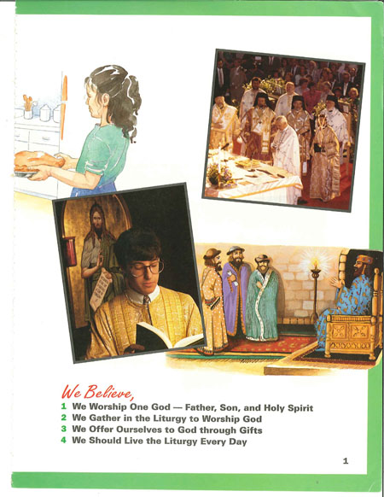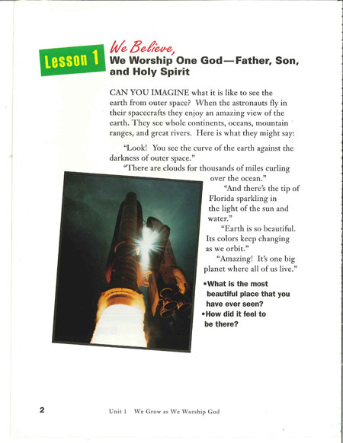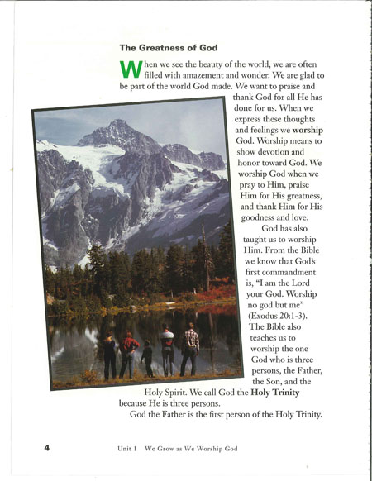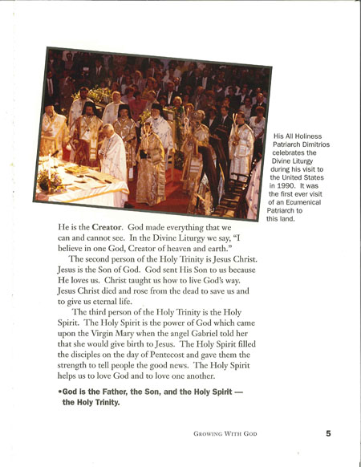

4th Grade: Growing with God Student Book
A program devoted to helping children learn how to use and appreciate the Bible. Also introduces examples of living the sacramental life—attending services, fasting, praying, observing feast days, helping others, learning about the saints and the Church of Christ. After this program, children love the Bible, and know how to refer to it in times of doubt and fear. Contains words to hymns and songs.
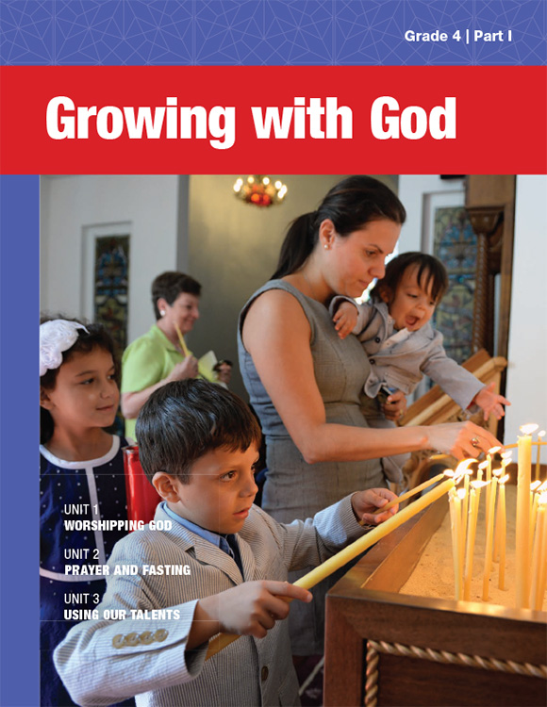
4th Grade: Growing with God Student Book (Part I)
A program devoted to helping children learn how to use and appreciate the Bible. Also introduces examples of living the sacramental life—attending services, fasting, praying, observing feast days, helping others, learning about the saints and the Church of Christ. After this program, children love the Bible, and know how to refer to it in times of doubt and fear. Contains words to hymns and songs.

For the New Series of Grade 4, we have created a program in three parts that approximate the flow of a school-year calendar:

PART I is comprised of three units, for a total of 15 lessons, as you might need for a fall semester.

PART II is also comprised of three units, but with a total of 12 lessons, appropriate for a spring semester.

PART III is “Feasts of the Virgin Mary,” an all-new unit created for the new series. Its 4 lessons can be taught as a unit or individually, to honor the feasts throughout the year.

This new series features new and engaging activities, content and layout.

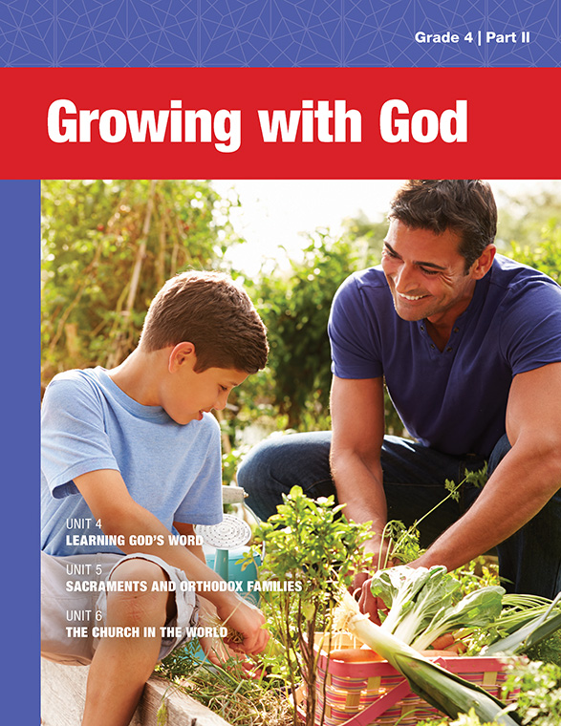
4th Grade: Growing with God Student Book (Part II)
A program devoted to helping children learn how to use and appreciate the Bible. Also introduces examples of living the sacramental life—attending services, fasting, praying, observing feast days, helping others, learning about the saints and the Church of Christ. After this program, children love the Bible, and know how to refer to it in times of doubt and fear. Contains words to hymns and songs.

For the New Series of Grade 4, we have created a program in three parts that approximate the flow of a school-year calendar:

PART I is comprised of three units, for a total of 15 lessons, as you might need for a fall semester.

PART II is also comprised of three units, but with a total of 12 lessons, appropriate for a spring semester.

PART III is “Feasts of the Virgin Mary,” an all-new unit created for the new series. Its 4 lessons can be taught as a unit or individually, to honor the feasts throughout the year.

This new series features new and engaging activities, content and layout.

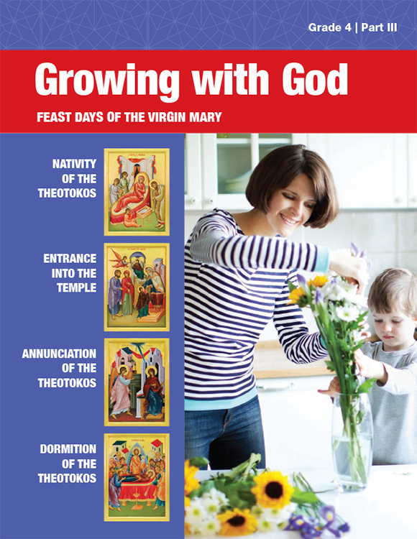
4th Grade: Growing with God Student Book (Part III)
A program devoted to helping children learn how to use and appreciate the Bible. Also introduces examples of living the sacramental life—attending services, fasting, praying, observing feast days, helping others, learning about the saints and the Church of Christ. After this program, children love the Bible, and know how to refer to it in times of doubt and fear. Contains words to hymns and songs.

For the New Series of Grade 4, we have created a program in three parts that approximate the flow of a school-year calendar:

PART I is comprised of three units, for a total of 15 lessons, as you might need for a fall semester.

PART II is also comprised of three units, but with a total of 12 lessons, appropriate for a spring semester.

PART III is “Feasts of the Virgin Mary,” an all-new unit created for the new series. Its 4 lessons can be taught as a unit or individually, to honor the feasts throughout the year.

This new series features new and engaging activities, content and layout.

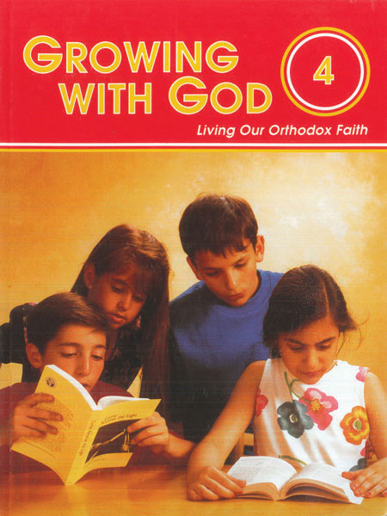
4th Grade: Growing with God Teacher Guide
A program devoted to helping children learn how to use and appreciate the Bible. Also introduces examples of living the sacramental life—attending services, fasting, praying, observing feast days, helping others, learning about the saints and the Church of Christ. After this program, children love the Bible, and know how to refer to it in times of doubt and fear. Contains words to hymns and songs.

