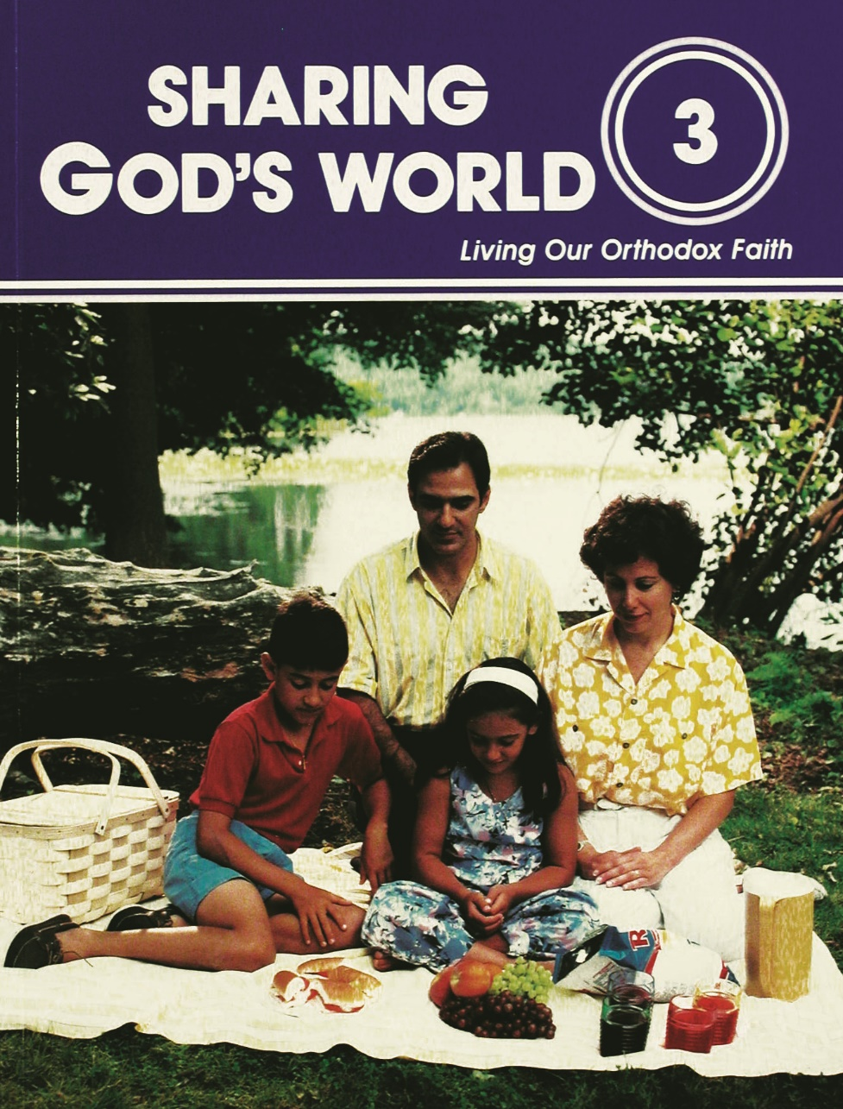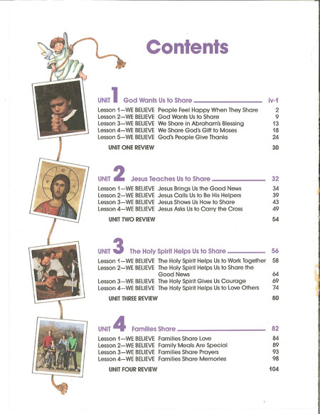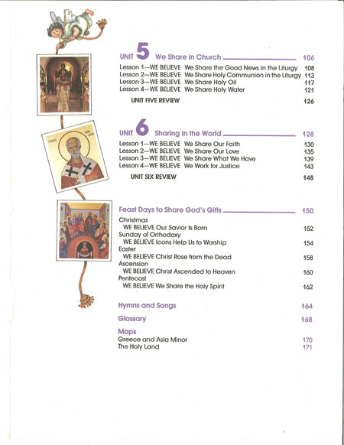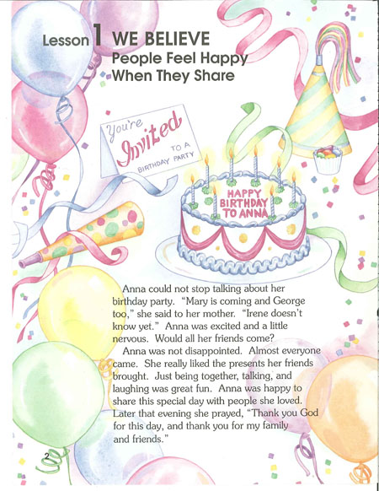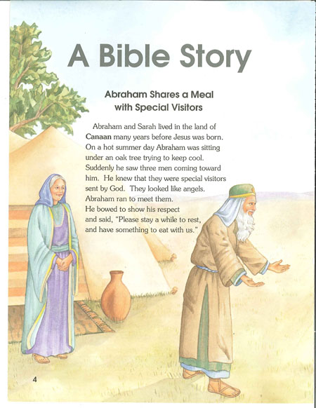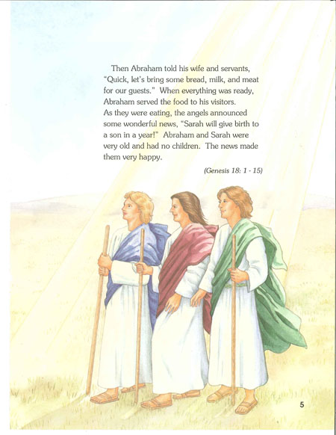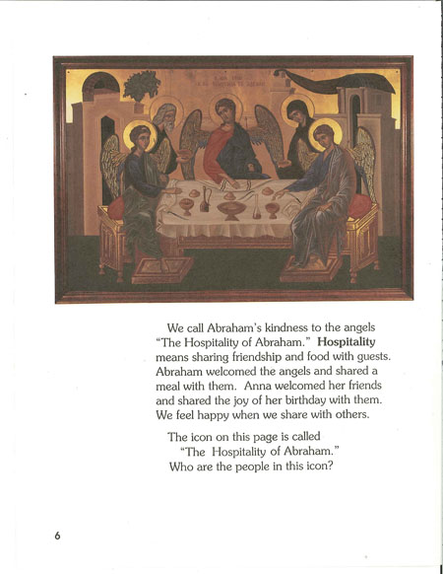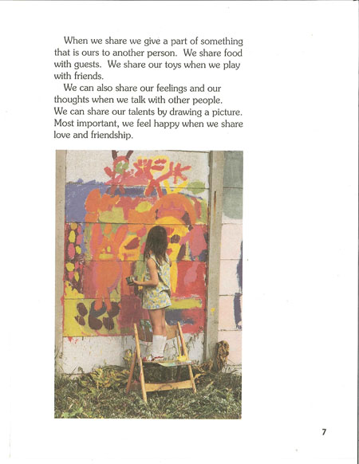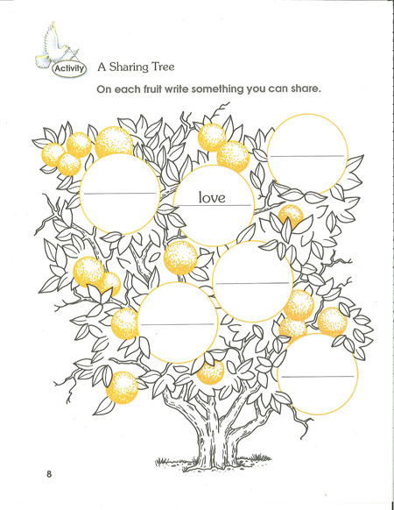
3rd Grade: Sharing God's World Student Book
Children learn about sharing through the example of Jesus and are inspired to observe these same examples in the Divine Liturgy, the Sacraments, and other services of the Church. From there they become caring, sharing individuals. Contains words to hymns and songs. Teacher’s Guide contains words and music for hymns and songs. Student Book.

3rd Grade: Sharing God's World Teacher Guide
Children learn about sharing through the example of Jesus and are inspired to observe these same examples in the Divine Liturgy, the Sacraments, and other services of the Church. From there they become caring, sharing individuals. Contains words to hymns and songs. Teacher’s Guide contains words and music for hymns and songs. Teacher Guide.

