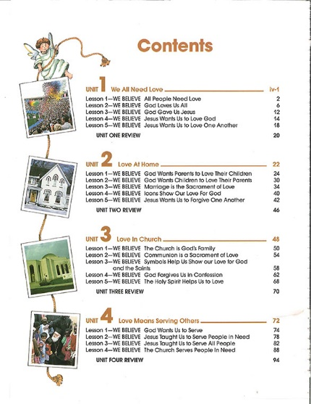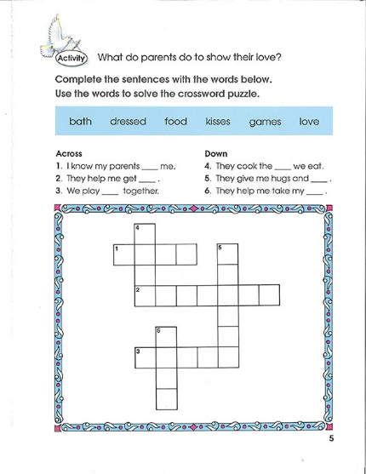

2nd Grade: Loving God Student Book
This program concentrates on the theme of “Loving God.” Through the example of men and women of the Bible, and of our Saints, children begin to understand right, wrong and forgiveness in the light of God’s love. They also learn the importance not only of loving God unconditionally, but also of respecting other people, of taking care of the environment, of doing good in His Name. Student Book.

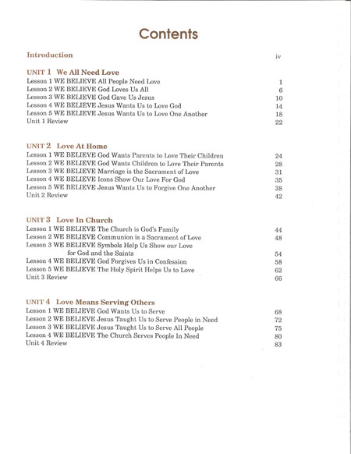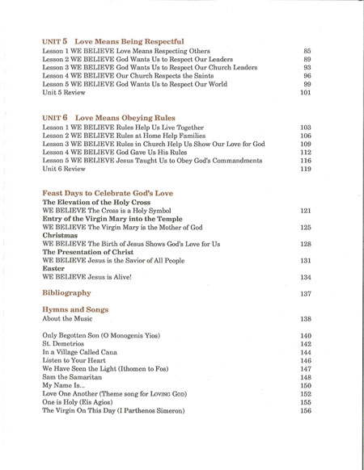

2nd Grade: Loving God Teacher Guide
This program concentrates on the theme of “Loving God.” Through the example of men and women of the Bible, and of our Saints, children begin to understand right, wrong and forgiveness in the light of God’s love. They also learn the importance not only of loving God unconditionally, but also of respecting other people, of taking care of the environment, of doing good in His Name. Teacher Guide.

