Orthodox Marketplace

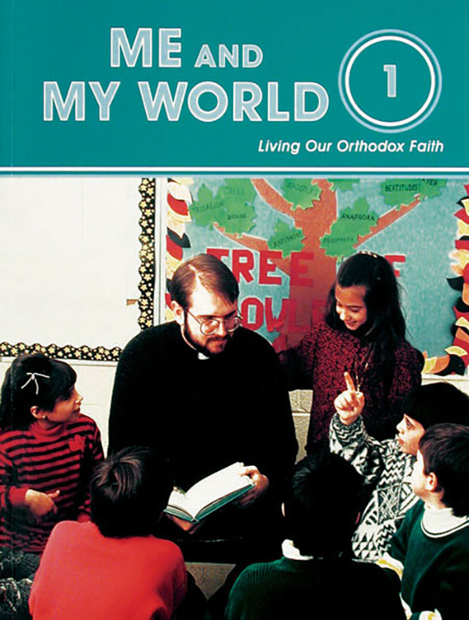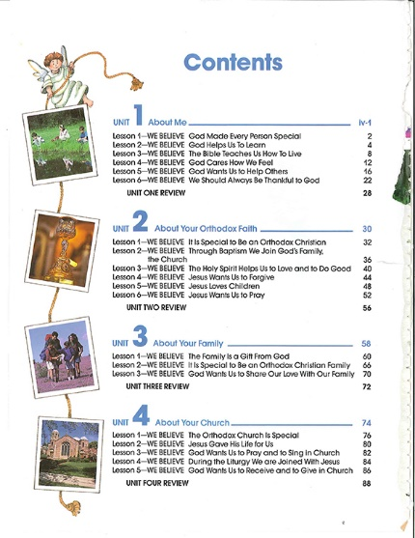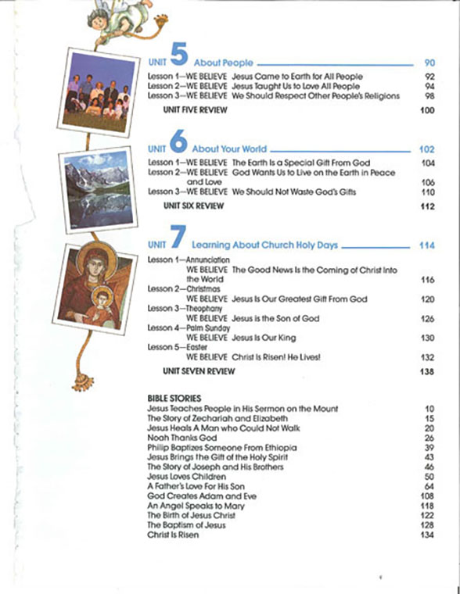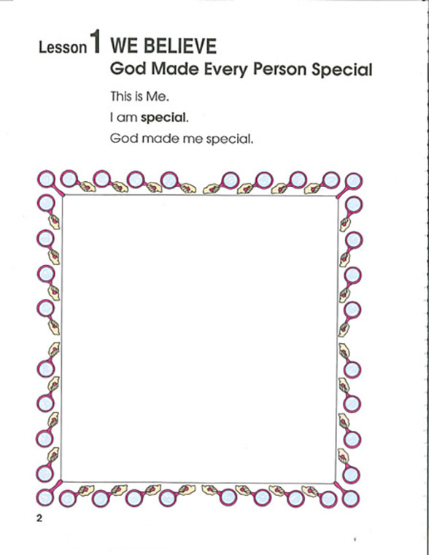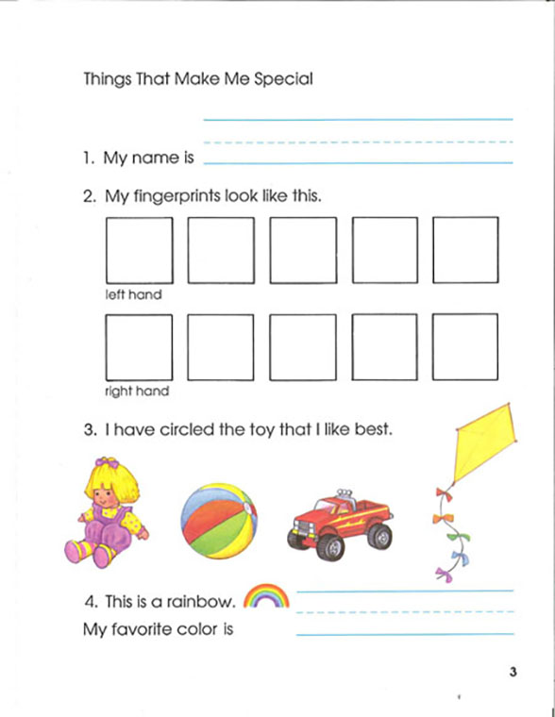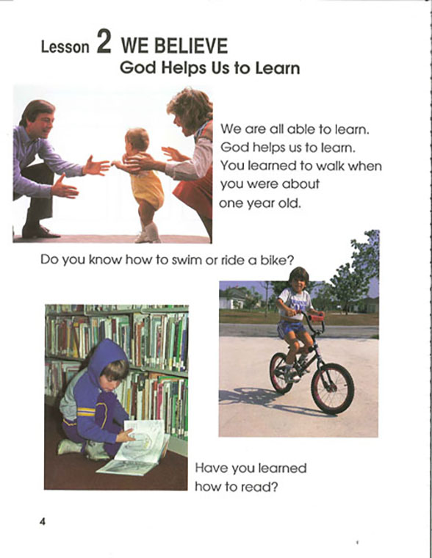
1st Grade: Me and My World Student Book
The focus of this program is on Creation as God’s gift. In discovering the world, the child understands that the family, friends, church school—all come from God. Through depictions of the daily experiences of God’s world, the child comes to realize that God is real, loving, and caring. Student Book.

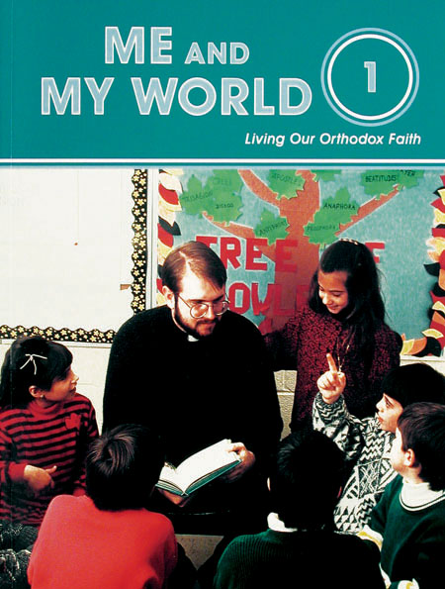
1st Grade: Me and My World Activity Book

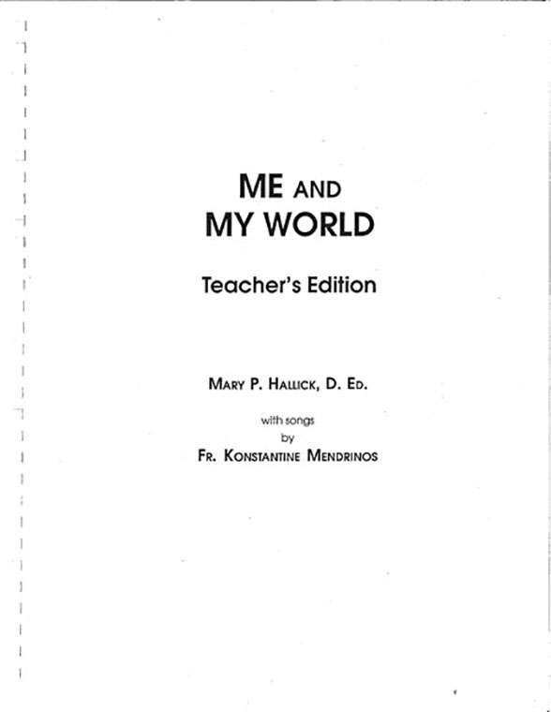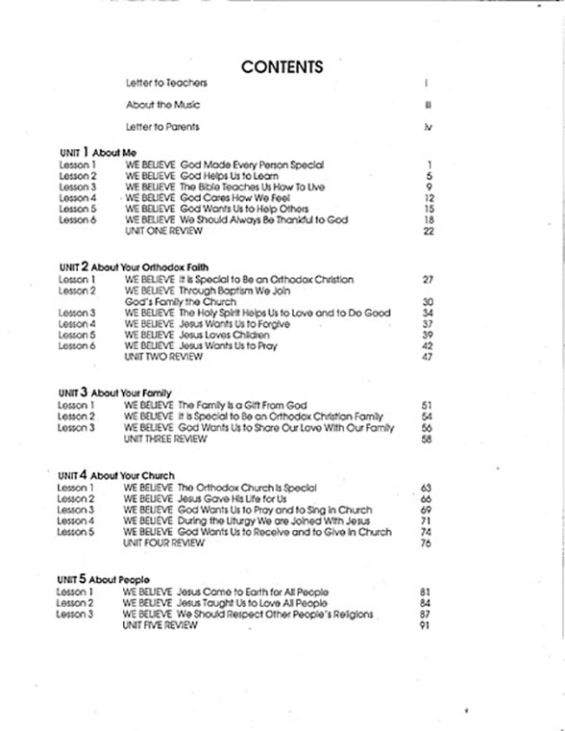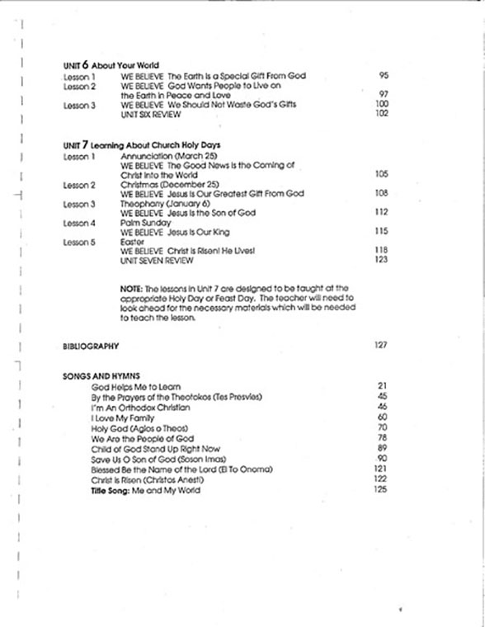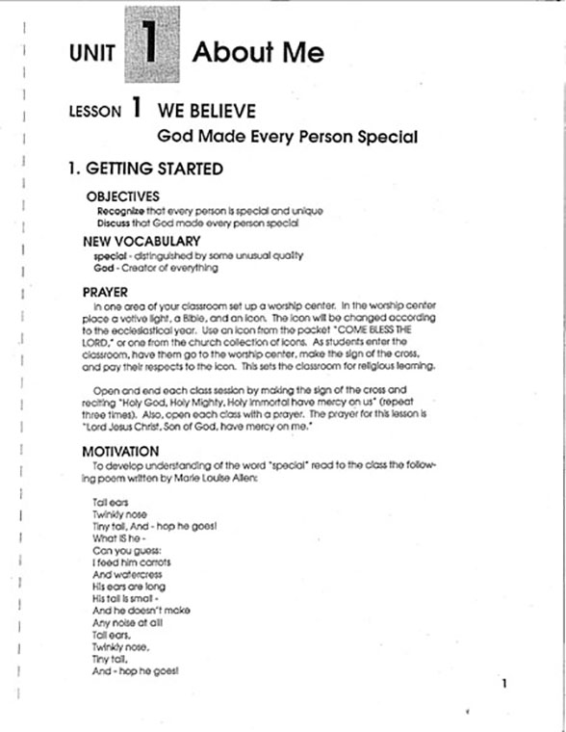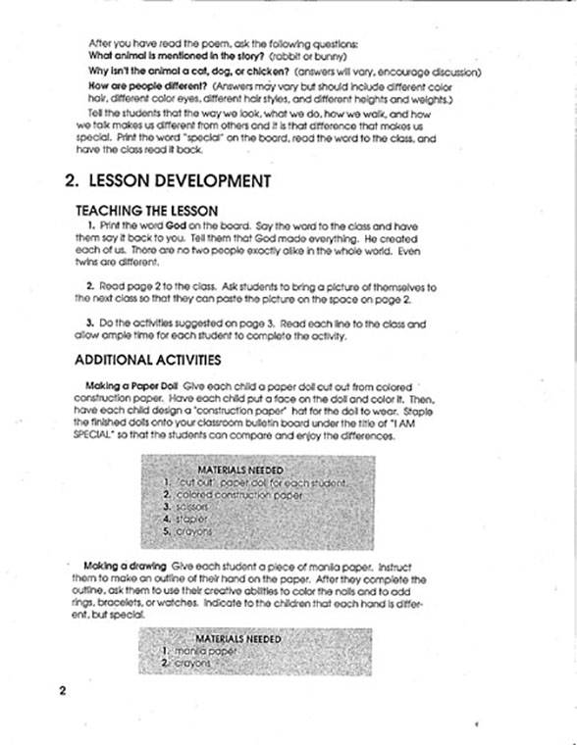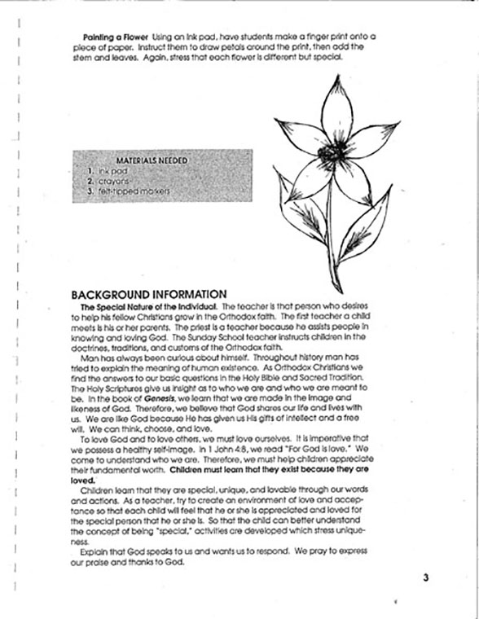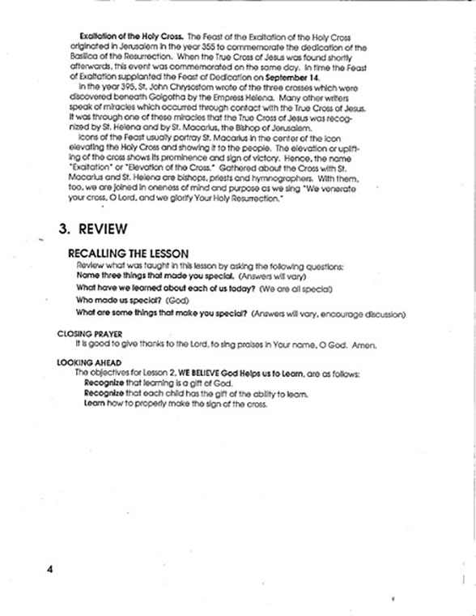
1st Grade: Me and My World Teacher Guide
The focus of this program is on Creation as God’s gift. In discovering the world, the child understands that the family, friends, church school—all come from God. Through depictions of the daily experiences of God’s world, the child comes to realize that God is real, loving, and caring. Teacher Guide.

